# CS 255 System Design Document

Noah Archibald

CS-255 - System Analysis and Design

Professor Habibi

10/17/2021

**Project Two:**

## UML Diagrams

### UML Use Case Diagram:

USE Case Overview of DriverPass System.

### UML Activity Diagrams*:*

Activity Diagram of User-Login Use Case.

Activity Diagram of Student Scheduling Use Case.

Sequence Diagram of User Log-in process.

### UML Class Diagram

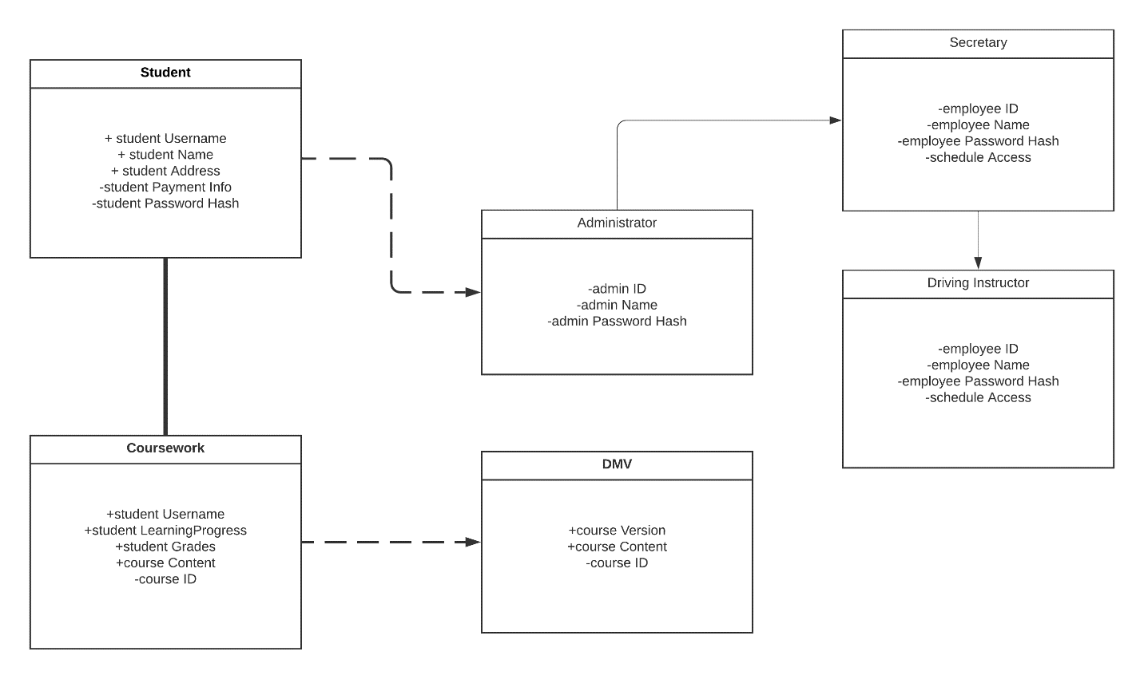

UML Class Diagram with relative attributes.

## Technical Requirements

Since this system is designed to be hosted via a third-party cloud hosting service, most of the hardware requirements will be handled externally. So, there should be few if any limitations for hardware running the servers that support the system. A crucial requirement, however, is a stable and reliable internet connection from the host to the user. This will ensure that the user’s experience on the website is responsive and efficient and guarantees that there will not be any wasted financial expenditures on unnecessary maintenance of hardware or other mitigating factors. The system should also be securely encrypted, ideally with some sort of cryptographic hash function like SHA-256, to ensure a secure connection between the server host and the system, as well as the user and the system. Incorporating two-factor authentication will also help secure the log-in credentials for all users and help when resetting passwords. It would also be useful for the admins of the system to use backend management tools to help facilitate the fast and efficient rollout of new updates to the website, as they are needed.